Cairo University  
Faculty of Computers and Information



**CS251**

**Software Engineering I**

Educational Games

Software Requirements Specifications

A2Z Team

# 12/2016

|  |  |  |  |
| --- | --- | --- | --- |
| ***ID*** | ***Name*** | ***Email*** | ***Mobile*** |
| 20140036 | Ahmed Mohamed Hassan | [Ahmedhassan199650@yahoo.com](mailto:Ahmedhassan199650@yahoo.com) | 01152003345 |
| 20140130 | Zyad Hassan Mohamed | Zyadhassan096@gmail.com | 01095907587 |
| 2010016 | Ahmed Hamdy Al-Sayed | Ahmedhamdi339@gmail.com | 01091708143 |

# Document Purpose and Audience

***Purpose:***

Show The Sequence Diagrams Of Register , Add Game And Play Game Use Cases .

Show Class Diagram .

***Audience***:

Compu-tech Company and teacher assistant.

# 

Class Diagram :

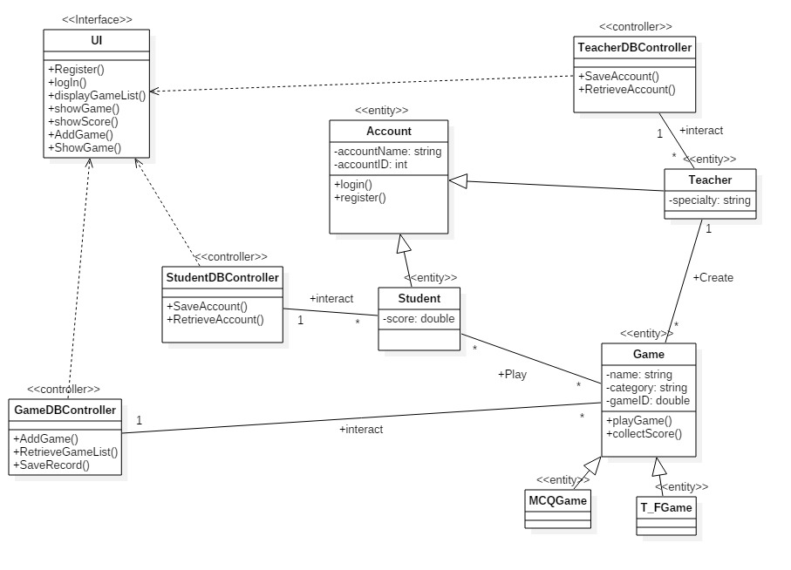

|  |  |  |
| --- | --- | --- |
| Class ID | Class Name | Disc & Resp |
| 1 | UI | This Interface The Functionalities of the System And Help User To Call Functions |
| 2 | Account | It Has Implementation of LogIn and Register And Has Attributes of User |
| 3 | Student | It has more attributes of Student account |
| 4 | Teacher | It has more attributes of Teacher account |
| 5 | Game | It Has Attributes of Games  And Can Collect Score Of Player |
| 6 | MCQGame | It Has Specific attributes of game |
| 7 | T_FGame | It Has Specific attributes of game |
| 6 | TeacherDBController | It Has Control On Teacher Data |
| 7 | StudentDBController | It Has Control On Student Data |
| 8 | GameDBController | It Has Control On Game Data  And Add new games |

1-Register Sequence Diagram :

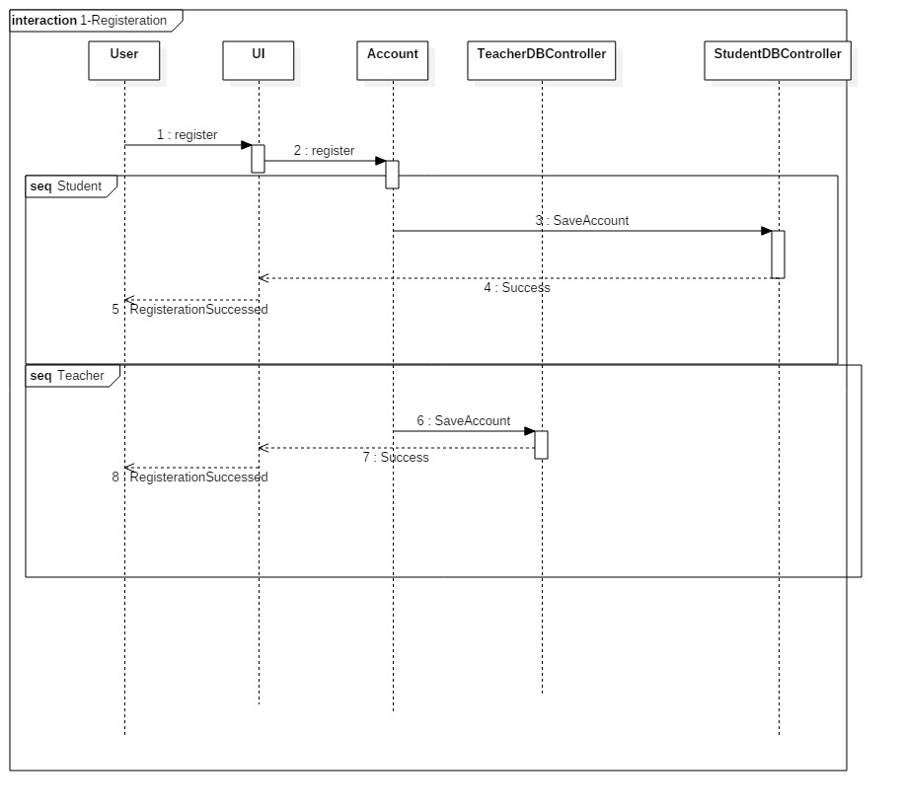

2-Add Game Sequence Diagram :

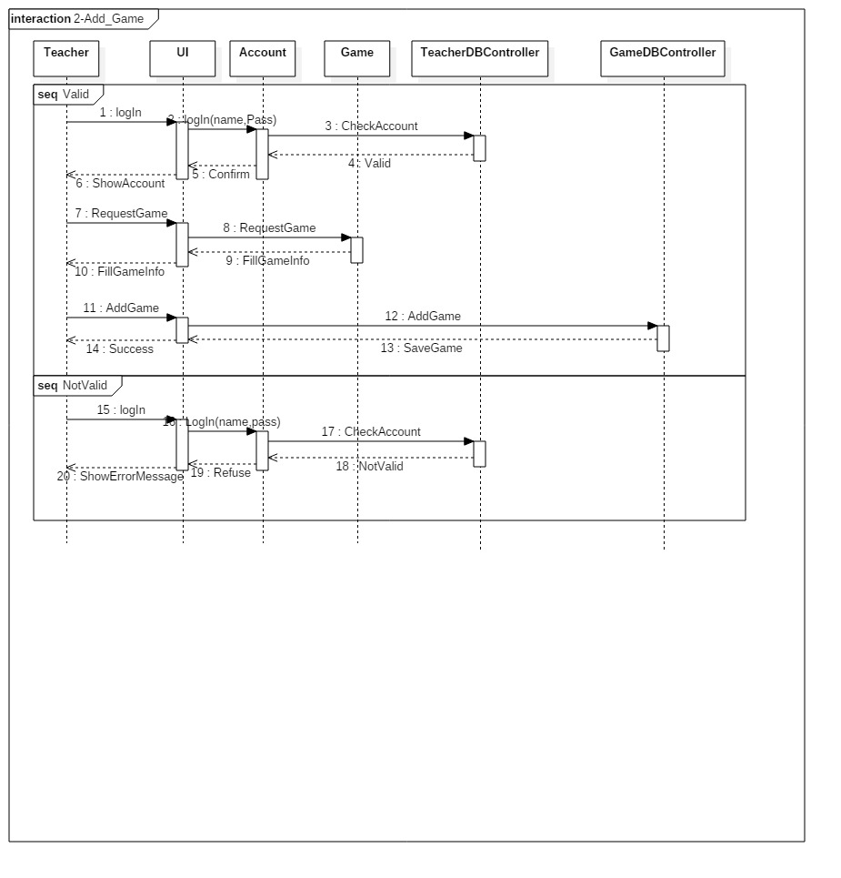

3 – Play Game Sequence Diagram :

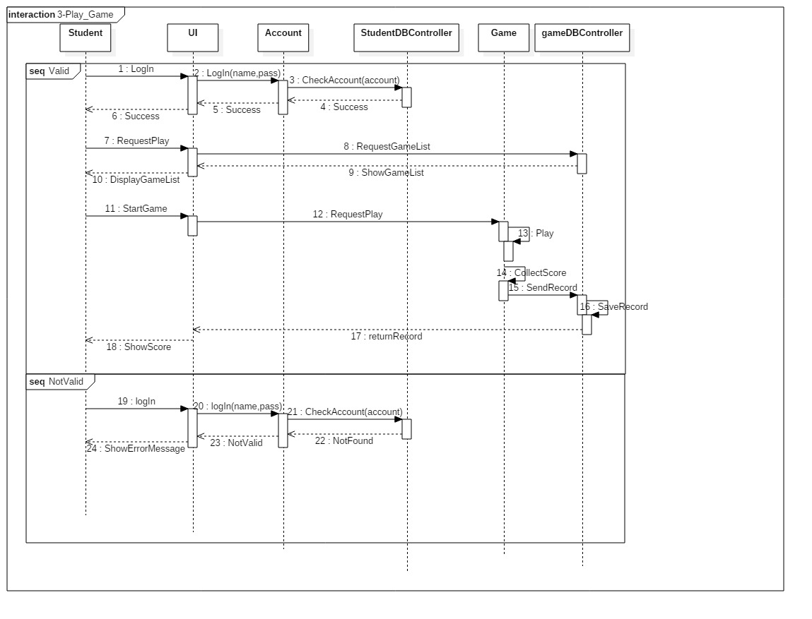

|  |  |  |
| --- | --- | --- |
| Class Name | Sequence Diagrams | Overall Used Methods |
| UI | 1 , 2 ,3 | All Functions |
| Account | 1 , 2 , 3 | LogIn , Register |
| Student | 1 , 3 | Log In , Register |
| Teacher | 1 , 2 | Log In , Register |
| Game | 2 , 3 | Play game , collect Score |
| MCQGame | 2 | Fill Game Data |
| T_FGame | 2 | Fill Game Data |
| TeacherDBController | 1 , 2 | Save Account , Check Account |
| StudentDBController | 1 , 3 | Save Account , Check Account |
| GameDBController | 2 , 3 | Save Record , Add Game |